Wwsq3+*Title-Guide for writting (13pt, black)
Last name- Last nam-+
e, Author nameª; Last name-Last name, Author name^{b} & Last name-Last name, Author name^{c} (10pt, black)
ªAuthor information – Filiation (Department,University, Country) and e-mail, (9pt)
^{b}Author information – Filiation (Department,University, Country) and e-mail,
^{c}Author information – Filiation (Department,University, Country) and e-mail
(Delete notes in red) It is recommended to identify with the same name in all scientific papers and to put hyphens in the last name so not to give rise to confusion..

Abstract (11pt, black italics)
These instructions have been prepared using the format should be used for writing the full text of the accepted comunications. The abstract will have a maximum of 500 characters, including spaces, or 100 words. The senders must supply the full text in a .doc file following these rules. (10pt, italics)

Keywords: a short list with a maximum of five keywords will be included. For example: design, systems, methods, processes, etc. They will be separated by commas.auiip

Guide for th writting of the full paper (11pt, black)
This document can be used as the format model of the full paper comunication.
Every text, figure and table is included within the margins of the template. (10pt)

  - Fonts and formats (10pt, black)
Fonts, sizes and spaces to be used are those indicated in this document, which can be used as a template.

    - Title (10pt, italics)
Titles will have a maximun of three levels numbered with the decimal system. Main titles (title 1) will be written in Times New Roman, black, 11. Second level (title 2) will be written in Times New Roman, black, 10. Third level (title 3) will be written in Times New Roman, italics, 11. All titles will have a later spacing of 6 pts. After each title does not leave a blank line, only one line will be left blank before starting a new section.

    - Figures feet and tables
The feet of figures and tables will be written in Times New Roman, italics, 8 pts. The texts included inside the figures must have the appropriate size to be legible, ie the font must not be less than 9 pts.

  - Graphs (drawings and photos) and tables
To facilitate the files transfer, a .jpg resolution of approximately 150 kB must be used.
The figures and tables will be placed in a place near the one that is cited for the first time. A foot with Fig. followed by the number will be placed below each image or photograph and a foot with Table followed by a correlative number under each table.

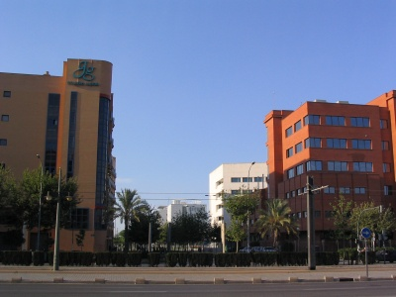
Fig. 1 Figure foot in italics (8pt, italics)

Figures, photographs and tables will be centered aligned. The tables will have border lines at the top and bottom and under the header.

Table 1. Sustainability schedule (9pt, black)
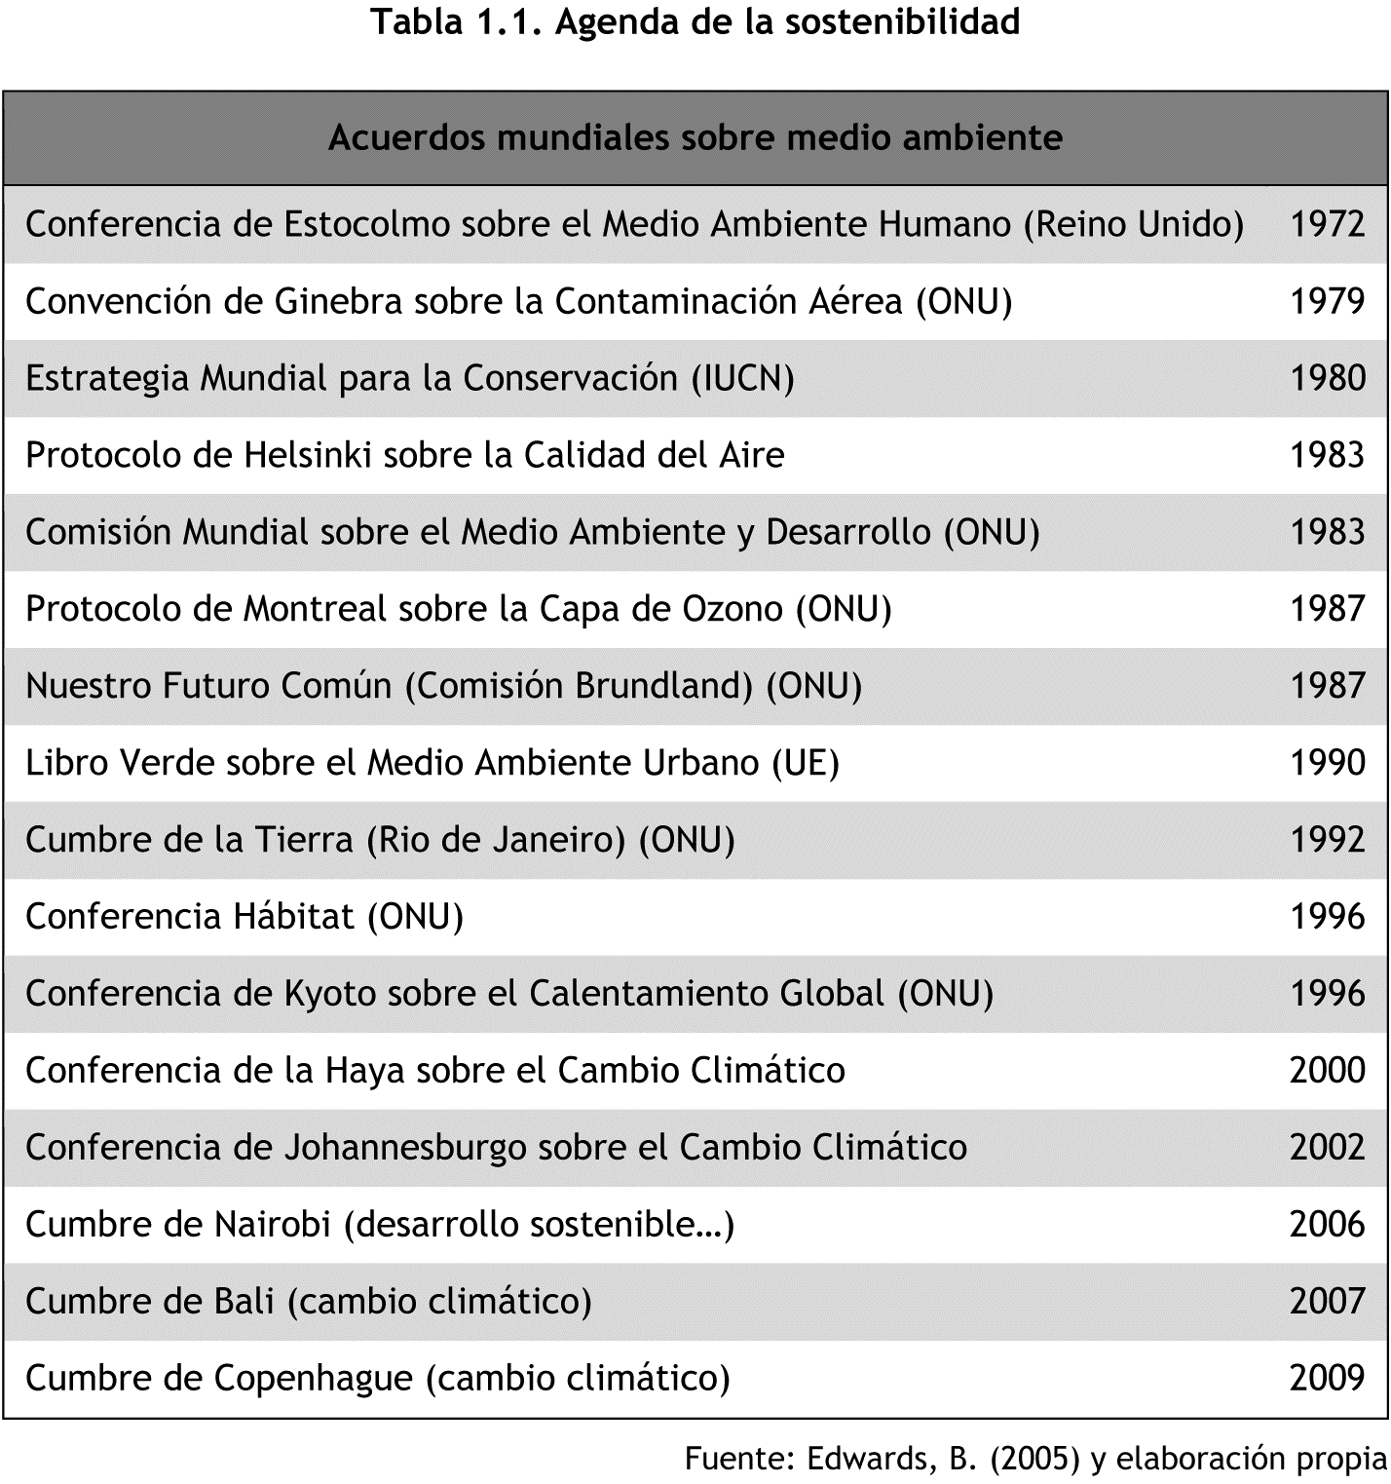
Source: Edwards, B (2005) (10pt)

Table 2. Factorial analysis results (9pt, black)
Scale dimension | Name | Form items
1 | Clarity | 1 to 7
2 | Motivation | 8 to 12
3 | Resources | 13 to 21
4 | Evaluation | 22 to 30

  - Formulas
Formulas and / or equations will be inserted using the equation editor integrated in Microsoft Word and it will have a number in parentheses to their right that indicates their order, for example:

(1) (11pt)

Quotes in the text
The author last name and the date of the work are included in parentheses within the sentence.
If the sentence includes the last name of the author, only the date is written in parentheses.
Viadero (2007) reports that an analysis of more than two hundred studies shows the correlation between teaching social skills and improving school performance.
If the author is not included in the sentence, the last name and the date are written in brackets.
An analysis of more than two hundred studies shows the correlation between social skills teaching and improvement of school performance (Viadero, 2007).
If the work has more than two authors, it is mentioned the first time with all the last names. In subsequent mentions, only the last name of the first author is written, followed by the phrase et al.
The term emotional intelligence was first used by Salovey and Mayer in 1990. (Álvarez Manilla, Valdés Krieg & Curiel de Valdés, 2006). Regarding school performance, Álvarez Manilla et al. (2006) found that emotional intelligence does not affect it.
If there are more than six authors, it is used et al. since the first mention.

References

  - General considerations
References style used corresponds to the 7th edition APA (American Psichological Association) style.
It must be in the alphabetical order by the first letter of the reference.
The works of the same author are arranged chronologically.
Each reference has the French paragraph format (hanging indent) and double spacing.

  - Electronic documents
It is not necessary to include the name of the database where the article was found, but it does in the case of thesis and e-books. The date on which the article was retrieved is not included. No point is written after the Web address (URL).

  - Periodic publications

2.4.1.Basic form
Last name, A. A., Last name, B. B. & Last name, C. C. (year). Paper title. Publication title, volume (number), pp. xx-xx. doi: xx.xxxxxxx

2.4.2. Paper with DOI, of EBSCO data base.
Demopoulos, A. W. J., Fry, B. & Smith, C. R. (2007). Food web structure in exotic and native mangroves: A Hawaii–Puerto Rico comparison. Ecologia,153(3), 675-686. doi: 10.1007/s00442-007-0751-x

2.4.3. Paper without DOI, of EBSCO.
Parés-Ramos, I. K., Gould, W. A. & Aide, T. M. (2008). Agricultural abandonment, suburban growth, and forest expansion in Puerto Rico between 1991 and 2000. Ecology & Society, 13(2), 1-19.

2.4.4. Web paper.
Cintrón, G., Lugo, A. E., Pool, D. J. & Morris, G. (1978). Mangroves of arid environments in Puerto Rico and adjacent islands. Biotropica, 10(2),110-121. Recuperado de http://www.jstor.org/pss/2388013

2.4.5. Weekly paper publication, of EBSCO
Viadero, D. (2007, 19 de diciembre). Social-skills programs found to yield gains in academic subjects. Education Week, 27(16), 1-15.

2.4.6. Daily paper publication, of the Web.
Duhigg, C. (2009, 12 de septiembre). Toxic waters: Clean Water laws are neglected, at a cost in human suffering. The New York Times. Recuperado de http://www.nytimes.com/2009/09/13/us/13water.html?em

  - Books

2.5.1.Basic forms for full books
Last name, A. A. (year). Title. City: Publisher.
Last name, A. A. (year). Title. Recovered from http://www.xxxxxx.xxx
Last name, A. A. (year). Title. doi: xx.xxxxxxxx
Last name, A. A. (Ed.). (Año). Title. City: Publisher.

2.5.2. Book with author
Goleman, D. (2000). La inteligencia emocional: Por qué es más importante que el cociente intelectual. México: Ediciones B.

2.5.3. Book with editor
Castillo Ortiz, A. M. (Ed.). (2000). Administración educativa: Técnicas, estrategias y prácticas gerenciales. San Juan: Publicaciones Puertorriqueñas.

2.5.4. Electronic book
Montero, M. & Sonn, C. C. (Eds.). (2009). Psychology of Liberation: Theory and applications. [Versión de Springer]. doi: 10.1007/ 978-0-387-85784-8 De Jesús Domínguez, J. (1887). La autonomía administrativa en Puerto Rico. [Versión de Library of Congress]. Recuperado de http://memory.loc.gov/cgibin/query/r?ammem/lhbpr:@field%28DOCID+@lit%28lhbpr33517% 29%29

2.5.5. Basic form for a chapter of a book.
Last name, A. A. & Last name, B. B. (year). Title of the chapter or entry. At Last name, A. A. (Ed.), Title of the book (pp. xx-xx). City: Publisher.
Last name, A. A. & Last name, B. B. (year). Title of the chapter or entry. At Last name, A. A. (Ed.), Title of the book (pp. xx-xx). City: Publisher. Recovered from http://www.xxxxxx
Last name, A. A. & Last name, B. B. (year). Title of the chapter or entry. At Last name, A. A. (Ed.), Title of the book (pp. xx-xx). City: Publisher. doi: xxxxxxxx.

2.5.6. Chapter of a printed book
Picó, F. (2004). Arecibo, sol y sereno. En Feliú Matilla, F. (Ed.), 200 años de literatura y periodismo: 1803-2003 (129-134). San Juan: Ediciones Huracán.

2.5.7. Entry with an author in an electronic reference
Graham, G. (2008). Behaviorism. En Zalta, E. N. (Ed.), The Stanford Encyclopedia of Philosophy (Otoño 2008 Ed.). Recuperado de http://plato.stanford.edu/archives/fall2008/entries/behaviorism

2.5.8. Entry without author in an electronic reference.
Agricultura sustentable. (s. f.). En Glosario de términos ambientales de EcoPortal.net. Recuperado de http://www.ecoportal.net/content/view/full/ 169/offset/0

  - Technical report

    - Basic form
Last name, A. A. (year). Title. (Report Num. xxx). City: Publisher.

    - Report with authors
Weaver, P. L., & Schwagerl, J. J. (2009). U. S. Fish and Wildlife Service refuges and other nearby reserves in Southwestern Puerto Rico. (General Technical Report IITF-40). San Juan: International Institute of Tropical Forestry.

    - Report from a government agency
Federal Interagency Forum on Child and Family Statistics. America’s Children: Key National Indicators of Well-Being, 2009. Washington, DC: U.S. Government Printing Office. Recuperado de http://www.childstats.gov/pubs/index.asp

  - Thesis

    - Basic form
Last name, A. A. (year). Title. (Unpublished thesis). Name of the institution, Localization.

    - Unpublished Thesis
Muñoz Castillo, L. (2004). Determinación del conocimiento sobre inteligencia emocional que poseen los maestros y la importancia que le adscriben al concepto en el aprovechamiento de los estudiantes. (Tesis inédita de maestría). Universidad Metropolitana, San Juan, PR.

    - Thesis with a commercial data base
Santini Rivera, M. (1998). The effects of various types of verbal feedback on the performance of selected motor development skills of adolescent males with Down syndrome. (Tesis doctoral). Disponible en la base de datos ProQuest Dissertations and Theses. (AAT 9832765)

    - Thesis in the Web
Aquino Ríos, A. (2008). Análisis en el desarrollo de los temas transversales en los currículos de español, matemáticas, ciencias y estudios sociales del Departamento de Educación. (Tesis de maestría, Universidad Metropolitana). Recuperado de http://suagm.edu/umet/biblioteca/UMTESIS/Tesis_Educacion/ARAquinoRios1512.pdf

- Submission of full texts of comunications

The full paper length must be between 1500 to 2000 words.

Deadline for reception SD2022 key dates HERE.

